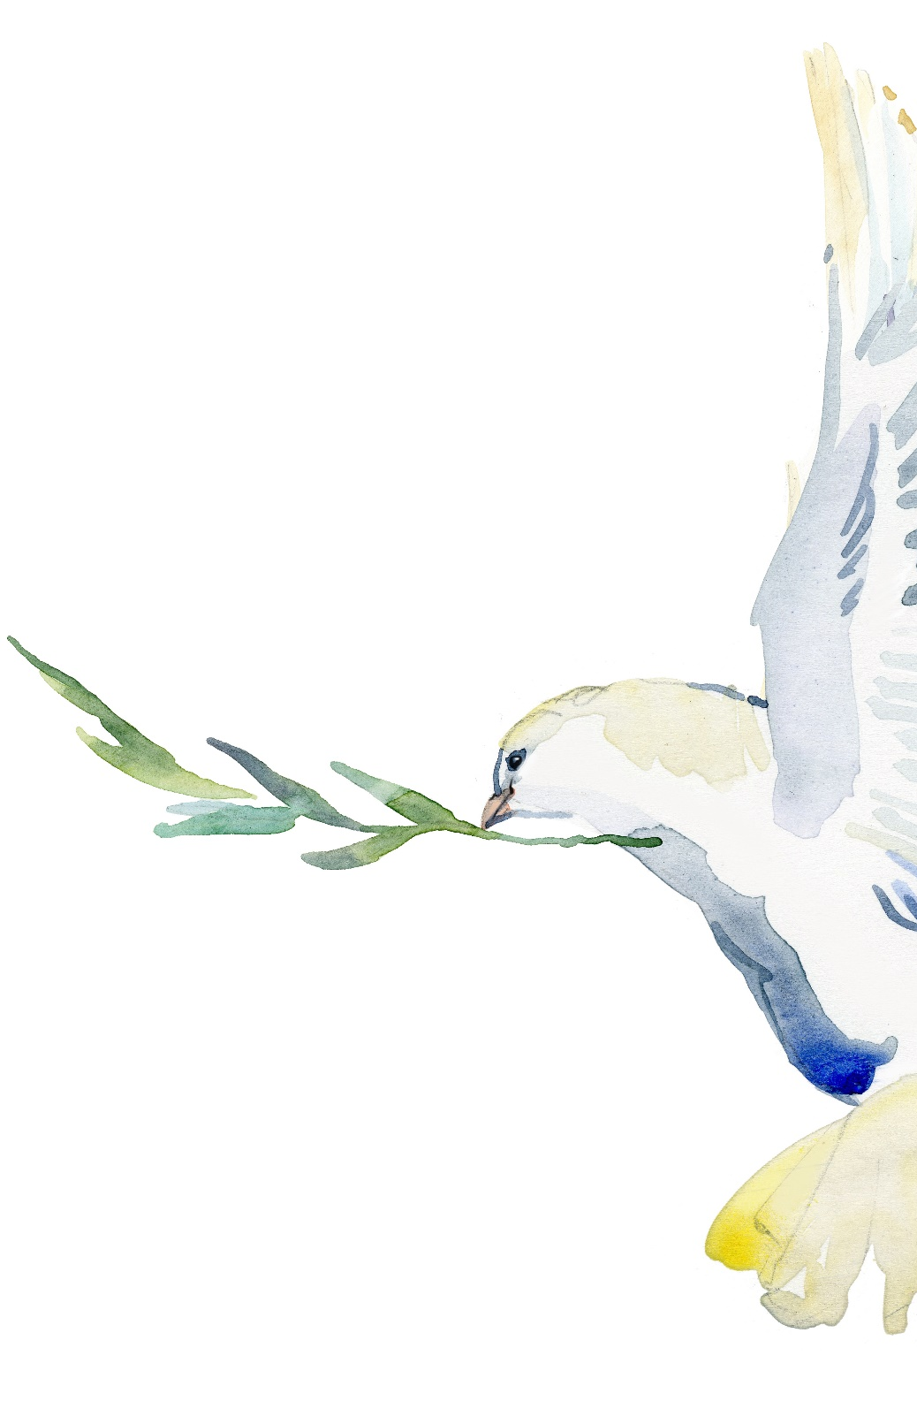
PEACE
JOY
HOPE
LOVE

Advent Studies 2023

This year the Ministry Development Committee invites you to reflect during December on four great Advent themes – Peace, Joy, Love and Hope. We have provided small shapes and words that reflect these themes. At the end of each week you might like to choose the words that have resonated with you. We suggest that you write them on the appropriate shape, then cut it out to hang on your Christmas tree. You might also like to write words on a shape to give to family or friends. This will encourage reflection on the theme of the week.

Week 1, December 1-7

PEACE
In the midst of the often hectic time leading up to Christmas, it is easy to become caught up in a frantic round of shopping, parties and general business. This week let us focus on Jesus’ words, “Peace I leave with you; my peace I give to you. I do not give to you as the world gives. Do not let your hearts be troubled, and do not let them be afraid.” John 14.27
During this week look for opportunities to be still. Breathe in the peace Jesus offers us. Notice the moments of calm in your days and thank God for these times.
We have chosen the symbol of a dove to remind us of this gift of peace. What other symbols remind you of peace?

Words about PEACE to reflect on.
1/12 Make me a channel of your peace:
Where there’s despair in life let me bring hope;
Where there is darkness, only light,
And where there’s sadness, ever joy.
St Francis
2/12 Blessed are the peacemakers, for they will be called children of God. Matthew 5:9
3/12 Be still and know that I am God. Psalm 46:10
4/12 All will be well, and all will be well, and all manner of things will be well. Mother Julian of Norwich
5/12 The peace of God is beyond measure.
6/12 For it isn't enough to talk about peace. One must believe in it. And it isn't enough to believe in it. One must work at it. Eleanor Roosevelt
7/12 Peace begins with a smile. Sister Teresa
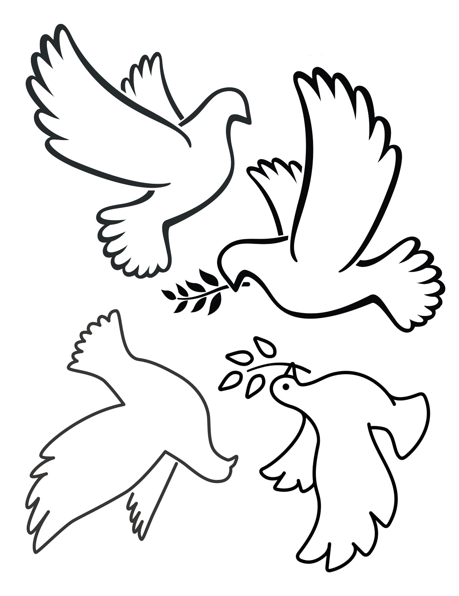

Week 2, December 8-14

JOY
“Joy to the world, the Lord has come.” The words of the old carol remind us that our God brings great joy to the world. For many people these weeks around Christmas time are difficult, rather than joyful. This can be a time when people remember lost friends or face family turbulence. Let’s use this week to find joyful moments in our own lives, to pray for those you find Christmas difficult and look for opportunities to share Christ’s joy with those we meet.
We have used the figure of an angel to represent joy, as it reminds us of the angels who brought the shepherds news of great joy and who sang God’s praises on the night Jesus was born.

Words about JOY to reflect on.
8/12 Joy to the world, the Lord is come!
Let earth receive her King;
Let every heart prepare Him room,
And heav’n and nature sing. Isaac Watts
9/12 Rejoice in the Lord always; again I will say, rejoice. Philippians 4:4.
10/12 "I've got that joy, joy, joy, down in my heart, down in my heart, down in my heart to stay!" George William Cooke 1925
11/12 He found that he actually had hind legs! Instead of dingy velveteen he had brown fur, soft and shiny, his ears twitched by themselves, and his whiskers were so long that they brushed the grass. He gave one leap and the joy of using those hind legs was so great that he went springing about the turf on them, jumping sideways and whirling round as the others did, and he grew so excited that when at last he did stop to look for the Fairy she had gone.” From the Velveteen Rabbit by Margery Williams 1922
12/12 Be as joyful as children this Christmas tide
13/12 Joy does not simply happen to us. We have to choose joy and keep choosing it every day. Henri Nouwen
14/12 In dark times embrace joy wherever you find it.

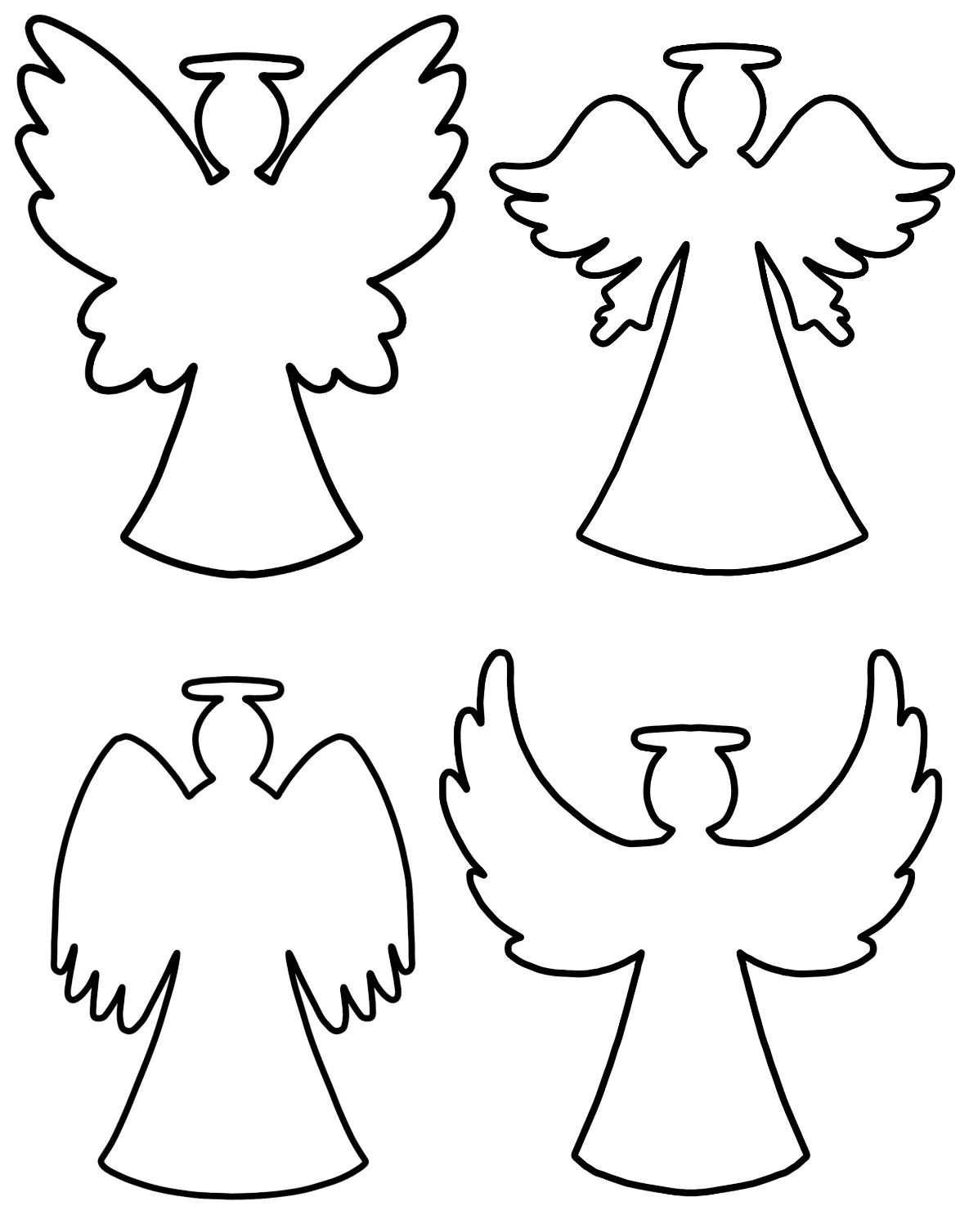

Week 3, December 15-21

LOVE
God expresses his great love for his creation in so many ways. In this Advent season we look at the way God comes to his people in human form, to show his love in a profound way. Christ was born, not in a palace or a beautiful home, but in a dusty stable, where the Son of God slept in an animal’s feed bin. The babe of Bethlehem became the world’s greatest teacher, the Son of God who came to show us how much God loves us and how far God will go to show us this love. This same Jesus promised that he will come again in glory to restore the world. The adult Jesus had no home of his own. He was rejected by religious leaders, and died a criminal’s death. Christ rose from the dead and has gone to prepare a place for us. God sent his Spirit to be with us. Such is God’s love for us. Think about the ways you experience God’s love for you this week. How can you share this love for others?
We have chosen a heart shape to remind us of God’s love for us this week and always. What else reminds you of God’s great love for you?

Words about LOVE to reflect on.
15/12 I am so glad that our Father in heav’n
Tells of His love in the Book He has giv’n;
Wonderful things in the Bible I see:
This is the dearest, that Jesus loves me. Philip Bliss
16/12 Do everything in love. Corinthians 6:14.
17/12 “True love is putting someone’s needs before your own” Olaf the Snowman from the 2013 Disney Film ‘Frozen’
18/12 Beloved, let us love one another, because love is from God; everyone who loves is born of G od and knows God. Whoever does not love does not know God, for God is love.” 1 John 4:7-
19/12 Love is the perfect gift to give and receive.
20/12 We look forward to the time when the power to love will replace the love of power. William Ellery Channing
21/12 God so loved the world that he gave his only Son.

Week 4, December 22-30

HOPE
Advent is a season of hope, as we look forward to God coming among us as a human child and to Christ’s coming again in glory. This week we celebrate the birth of Jesus on Christmas Day. The birth of any baby is a time of hope, a time of dreaming about possibilities. How much more does the birth of Jesus bring us a sense of deep hope – hope for our troubled world and hope in our own lives. It also offers us unlimited possibilities, as we experience the power of God’s Holy Spirit within us.
The wise men followed a star to find the Holy Child. For them the star was a sign of hope. We have used the star as a sign of hope for us this week.

Words about HOPE to reflect on.
22/12 Blessed assurance, Jesus is mine!
O what a foretaste of glory divine!
Heir of salvation, purchased of God,
Born of his Spirit, washed in his blood. Fanny Crosby
23/12 Put your hope in God. Psalm 42:11
24/12 “Hope is being able to see the light despite all of the darkness.” Desmond Tutu
25/12 For unto us a child is born.
26/12 “I believe that imagination is stronger than knowledge. That myth is more potent than history. That dreams are more powerful than facts. That hope always triumphs over experience. That laughter is the only cure for grief. And I believe that love is stronger than death.” Robert Fulgham from ‘All I really need to know I learned in Kindergarten: Uncommon thoughts about Common things’ 1986
27/12 In the midst of winter, I learnt that there was in me an invincible summer. Albert Camus
28/12 We must accept finite disappointment, but never lose infinite hope. Martin Luther King, Jr.

2023
www.ballaratanglican.org.au/mdc

